**# How to submit or edit files to the class Github repository**

Sometimes during class you will need to contribute files to the class repository:

(a) to submit your Balsam fir data as a comma separated variable (.csv) file;

(b) to submit a strategy for the evolutionary game (a .R file); or

(c) to edit an existing file such as ‘Duck_dates.csv’.

To notify me, as the administrator for the BIOL-3295 repository, that you recommend to make changes to the repository you will need to submit a **Pull Request**.

The two options to submit or edit repository files are:

1. Via Github Desktop or,
2. Directly to the GitHub repository

Both approaches will require Github credentials; you will need to create a branch (by forking the repository), and then submit the ‘pull request’.

**## 1) Via GitHub Desktop**

1. Open GitHub Desktop. Choose the BIOL-3295 repository, and in the branch tab, create a new branch:

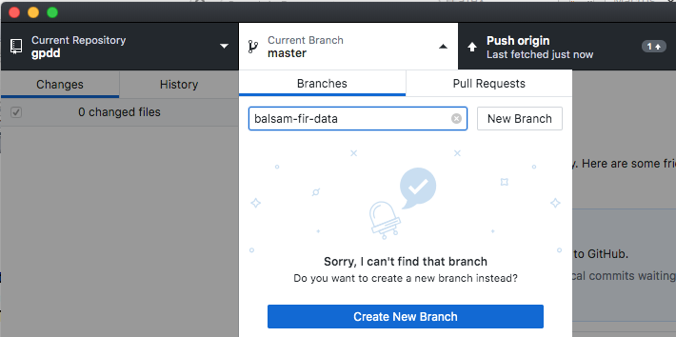

In the photo above my repository is ‘gpdd’ only because I am doing a test example for a repository that I am not an administrator on.

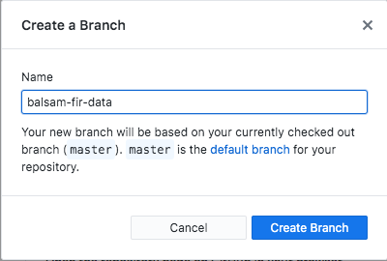

1. With GitHub Desktop showing Current repository as ‘BIOL-3295’ and Current Branch as ‘balsam-fir-data’ (or whatever the name is of the branch you created), open Excel or other software as appropriate, and enter your data. If you are editing an existing file, then open that file in the location that it is saved to when you clone the BIOL-3295 repository (i.e., when I clone the repository, ‘BIOL-3295’ appears as a folder on my Desktop. I will navigate the folders here, and find the file I want to edit).
2. For the balsam fir data save as a .csv file (even though you were working in Excel). You should choose a name for your file that is distinct from any other files in the “Lab 2” directory of the BIOL-3295 Github repository (i.e., try not to give your file the same name as another group might choose).
3. In Excel, Select "File" -> "Save As..." -> In the "Format" drop-down menu select "Comma-Separated Values (.csv)" -> Click "Save". This may prompt the warning "This workbook contains features that will not work or may be removed if you save it in the selected file format. Do you want to continue?" - Click "Continue" to proceed with saving the file. If you are prompted by an additional warning concerning the encoding of the file, select the option "UTF-8 encoding" to prevent including unwanted special characters in your file.

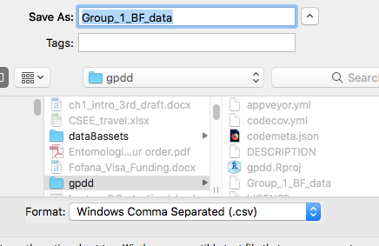

Sometimes you will try to exit Excel and be asked “Do you want to save the changes you made to …csv”. If you click “Save” and try and exit the same message will appear again, but you can click “Don’t Save”, and as long and no new changes have been made, no work will be lost.

1. Go to Github Desktop and make sure you have “BIO-3295” as the repository and your new branch as the “Current Branch”. You should see something like this:

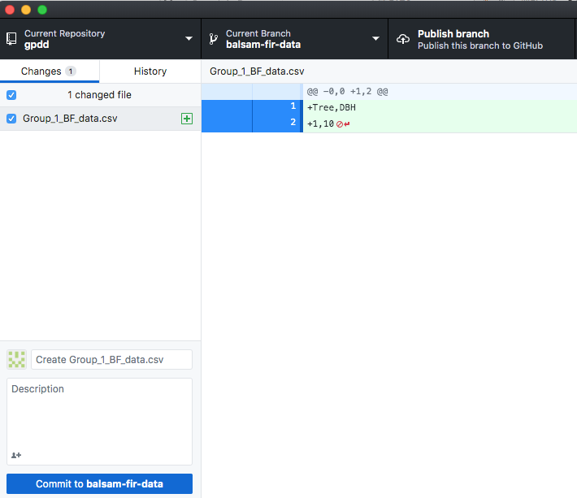

The left panel will show the new file that you have created or the edits that you have made. Commit these changes to your branch by clicking the blue button ‘Commit to balsam-fir-data’. If this button isn’t available you may need to add a title and a description.

1. Now publish your branch:

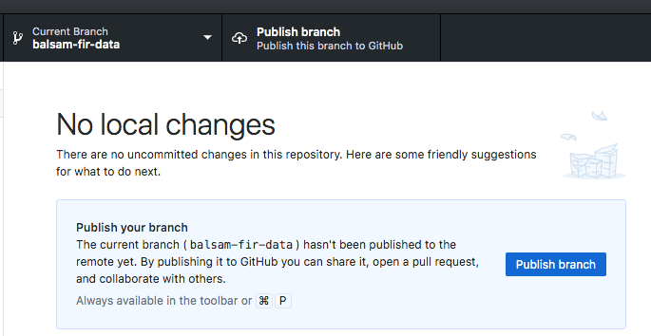

1. Finally, you need to submit a Pull request: <https://help.github.com/en/articles/creating-a-pull-request-from-a-fork>. As administrator for the BIOL-3295 repository, I will be notified to review the changes that you have proposed. I can approve or reject the changes and then merge into the master branch.
2. If you have problems with authentication, try the following:
   1. Generate a personal access token: <https://help.github.com/en/articles/creating-a-personal-access-token-for-the-command-line>
   2. In Github Desktop, log out of your Github account and then log in with your password as your access token (for example, as explained here: <https://itnext.io/how-to-use-github-desktop-with-gitlab-cd4d2de3d104>. Use the username that you usually use.

**## 2) Directly to the GitHub repository**

1. For the online GitHub class repository, navigate to the folder where you wish to create or edit a file. For example, for the Balsam fir lab navigate to the “Lab 2” folder.

2) Click on “Create new file” – you must be signed in to your Github account to do this.

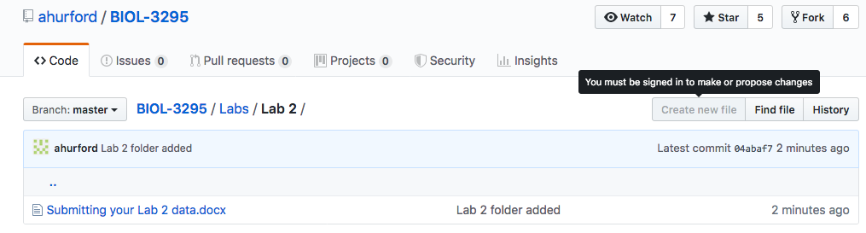

You should see a warning like this:

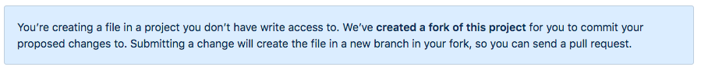

3) If you are creating a data file (i.e., the balsam fir lab, or editing duck_dates.csv), the data may need to be in tabular form, and we prefer comma separated variable file format for cross-compatibility. See “Example data entry.csv” in the Handouts folder (open this file in a text editor such as Microsoft Word or TextEdit) or see the photo below. In csv format:

* Each row must have exactly the same number of commas
* Place a comma where you would like to start a new column
* Do not add in any unnecessary spaces
* Words should be enclosed in “”
* Each new line will be a new row
* Name your file with the .csv extension and with a different name than any other files in the Lab 2 directory.

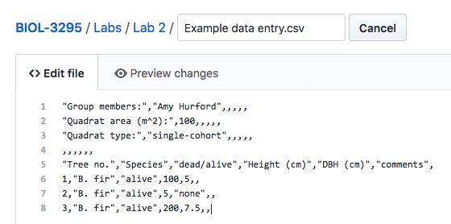

If you are editing, navigate in the online repository to the file you want to edit and click on the pen icon. The data may be in .csv format (see the bullet points above regarding the .csv data format).

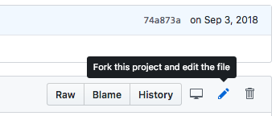

You should see this warning:

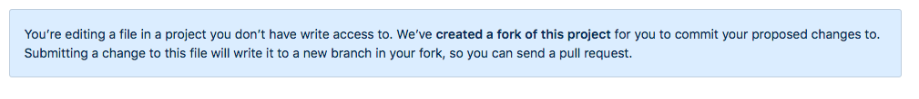

Note: If you are creating a new csv file, a shortcut might be to enter your data into Excel, save as a .csv file (see step 4) for the Github Desktop section, if needed), then open the file in a text editor such as Microsoft Word or TextEdit, which should give a format similar to that shown above with commas and “”. Then copy and paste into the file you have created online on GitHub and add any missing features, i.e., for my test example this approach yielded all the commas that I needed, but didn’t produce the “” around the names. You could add this in after pasting onto the online file, or it should be fine to submit without these “” (we’ll just have to do more data cleaning later).

1. Once you have entered all your data into the file you’ve made online, please copy it and save a local version (as .csv or .txt) for your records, just in case there are problems, so you don’t have to re-enter the data again.
2. When you have finished then “Propose file change” (or something similar, possibly “Commit changes”)

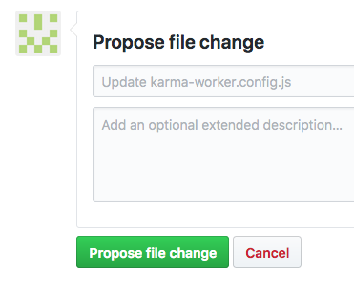

1. Create a pull request as follows: <https://help.github.com/en/articles/creating-a-pull-request-from-a-fork>. As the administrator of BIOL-3295 this will notify me of your proposed changes, which I can then approve or reject, and merge into the master branch.
2. If you encounter problems, please come and see me so I can resolve them.